High-Level Design (HLD)

Table of Contents

Scalable Disk Monitoring Solution for Customer ABC 2
1. Purpose 2
2. Existing AWS Organization Structure 3
3. Proposed Solution Overview 3
4. Major Solution Components 4
4.1 Ansible Control Node 4
4.2 Amazon S3 Artifact Repository 4
4.3 AWS Systems Manager 4
4.4 Amazon CloudWatch Agent 4
4.5 CloudWatch Cross-Account Observability 4
4.6 CloudWatch Alarms and Amazon SNS 4
4.7 AWS Lambda 4
5. End-to-End Operational Flow 4
6. Linux and Windows Monitoring 5
7. Account Vending and Automated Onboarding 5
8. Network and Connectivity Requirements 6
9. Security Considerations 6
10. Monitoring and Alerting Strategy 6
11. Scalability and Future Enhancements 7
12. Assumptions and Dependencies 7
13. Expected Outcome 7

Scalable Disk Monitoring Solution for Customer ABC

1. Purpose
The purpose of this solution is to implement a scalable and secure disk monitoring framework across Customer ABC's AWS environment. The solution will monitor disk utilization on Linux and Windows EC2 instances across multiple AWS accounts and provide centralized visibility, alerting, and notification capabilities to the operations team.
The solution will leverage the existing AWS Control Tower landing zone, Ansible for configuration orchestration, AWS Systems Manager (SSM) for remote execution, and Amazon CloudWatch for metric collection, centralized observability, and alarm management.

2. Existing AWS Organization Structure
Customer ABC has an existing AWS Organizations and Control Tower setup with the following organizational structure:
- Management Account: Manages AWS Organizations, Control Tower, and account provisioning through Account Factory or Account Factory for Terraform (AFT).
- Security OU: Contains the centralized Log Archive Account and Audit Account for centralized logging, security monitoring, and audit activities.
- Shared Services OU: Contains the Shared Services Account, which hosts the Ansible control node, S3 repository for monitoring-agent artifacts and configuration files, and supporting automation components.
- Custom OU: Contains application-specific workload accounts, including Production, Pre-Production, Non-Production, and other environment-specific accounts.
The proposed solution will integrate with the existing landing zone without requiring a redesign of the current organizational structure.

3. Proposed Solution Overview

3.1 Landing zone landscape
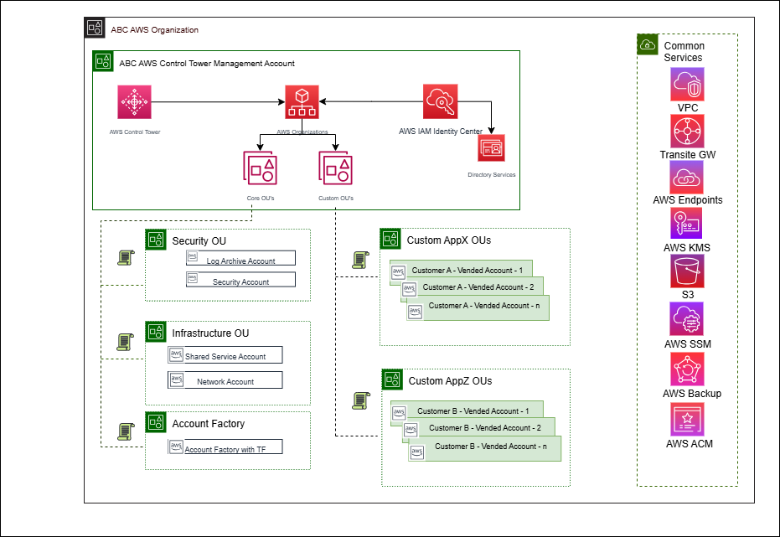

3.2 Solution HLD

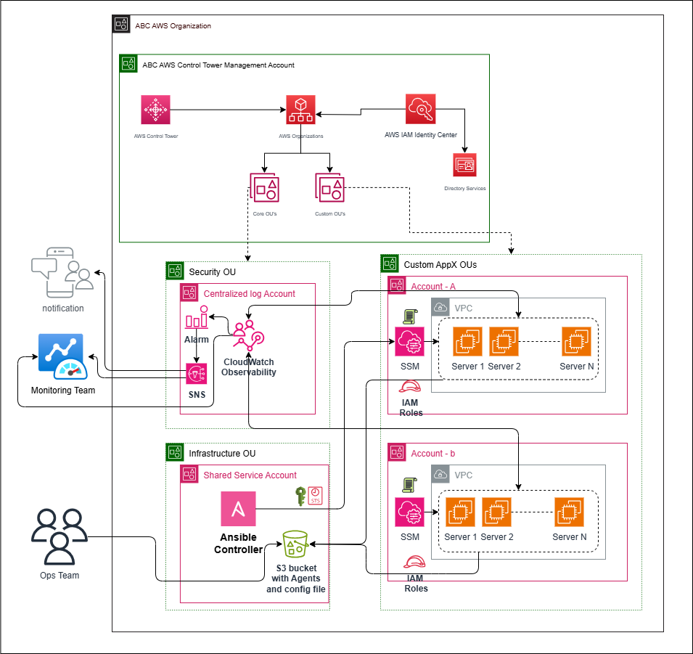

The solution will use Ansible as the central orchestration mechanism to deploy and configure the Amazon CloudWatch Agent on eligible Linux and Windows EC2 instances across workload accounts.
Ansible will execute from a dedicated Linux instance in the Shared Services Account. Cross-account access will be established using AWS STS and dedicated IAM roles in the target workload accounts. AWS Systems Manager will be used to execute the required installation and configuration operations on the target EC2 instances without requiring direct SSH or WinRM connectivity from the Ansible control node.
The CloudWatch Agent installation packages and configuration files will be maintained in a private S3 bucket in the Shared Services Account. EC2 instances will retrieve the required artifacts through authorized IAM roles and private network connectivity.
The agent will collect operating-system-level disk metrics and publish them to Amazon CloudWatch in the respective workload accounts. CloudWatch cross-account observability, configured through Observability Access Manager (OAM), will provide centralized visibility into supported metrics and logs from the linked source accounts.
CloudWatch alarms and SNS notifications will be configured to notify the monitoring team when disk utilization breaches defined thresholds. Automation will ensure that the monitoring configuration is consistently applied to newly provisioned accounts and instances.

4. Major Solution Components

4.1 Ansible Control Node
A dedicated Linux EC2 instance in the Shared Services Account will host Ansible and execute the disk monitoring playbooks. The playbooks will discover eligible EC2 instances based on approved resource tags, validate their operating-system type and SSM management status, and orchestrate the installation and configuration of the CloudWatch Agent.

4.2 Amazon S3 Artifact Repository
A private S3 bucket in the Shared Services Account will store approved CloudWatch Agent installation packages, operating-system-specific configuration files, and other required deployment artifacts. Access will be restricted through least-privilege IAM policies, bucket policies, encryption, and appropriate artifact integrity controls.

4.3 AWS Systems Manager
AWS Systems Manager will be used to manage supported EC2 instances and execute installation, configuration, and validation commands. The SSM Agent must be installed, running, and registered on each target instance. Amazon-provided AMIs commonly include the SSM Agent; custom and imported images will be validated as part of onboarding.

4.4 Amazon CloudWatch Agent
The CloudWatch Agent will collect disk utilization metrics from Linux filesystems and Windows logical disks. The configuration will define the required metrics, collection intervals, filesystem or volume filters, and metric dimensions.

4.5 CloudWatch Cross-Account Observability
CloudWatch Observability Access Manager will be configured with a monitoring-account sink and the required source-account links. This will enable centralized access to supported metrics and logs across linked workload accounts. OAM will provide centralized visibility; it will not automatically copy every telemetry stream or create all required alarms.

4.6 CloudWatch Alarms and Amazon SNS
CloudWatch alarms will evaluate disk metrics against defined thresholds. Alarm actions will publish notifications to approved SNS topics, which will deliver alerts to the monitoring team or integrate with the enterprise incident-management platform.

4.7 AWS Lambda
A Lambda function may be used to automate the creation or reconciliation of CloudWatch alarms and their notification actions for newly provisioned accounts or newly onboarded instances. The function will use idempotent logic and explicitly authorized IAM permissions to prevent duplicate alarms and unauthorized cross-account changes.

5. End-to-End Operational Flow
- A workload account is provisioned through AWS Control Tower Account Factory or AFT.
- The account baseline automatically deploys the required IAM roles, SSM prerequisites, resource tags, network endpoints, and observability configuration.
- Ansible discovers eligible EC2 instances using the approved disk monitoring tag and verifies their operating-system type and SSM management status.
- Ansible assumes the authorized cross-account IAM role through AWS STS using temporary credentials.
- Ansible invokes AWS Systems Manager Run Command or an approved SSM Automation workflow to install or update the CloudWatch Agent.
- The target instance retrieves the approved installation package and operating-system-specific configuration from the S3 repository using authorized IAM access.
- The CloudWatch Agent starts collecting filesystem and logical-disk utilization metrics and publishes them to CloudWatch in the workload account.
- CloudWatch OAM provides centralized visibility into the supported telemetry from linked accounts.
- CloudWatch alarms evaluate the configured disk thresholds and trigger SNS notifications when the defined conditions are met.
- The monitoring team reviews the centralized dashboards and responds to alerts according to the operational support process.

6. Linux and Windows Monitoring
The solution will support both Linux and Windows EC2 instances through operating-system-specific CloudWatch Agent configurations.
For Linux, the agent will collect filesystem utilization metrics for approved mount points and exclude irrelevant pseudo-filesystems where appropriate.
For Windows, the agent will collect logical-disk utilization metrics for the selected drive volumes and exclude volumes that are not relevant to operational capacity monitoring.
The playbook will identify the operating-system family and apply the corresponding installation procedure and configuration. The collection interval, metric dimensions, and alarm thresholds will be standardized wherever applicable.

7. Account Vending and Automated Onboarding
The monitoring solution will be integrated into the existing account vending process through Control Tower and AFT customizations, as appropriate.
Each newly provisioned workload account will receive the required cross-account IAM role, EC2 instance permissions, SSM prerequisites, CloudWatch observability configuration, approved monitoring tags, and alarm provisioning configuration.
The account baseline will ensure that future workload accounts follow the same security and monitoring standards without requiring manual configuration. Account-level onboarding and instance-level agent deployment will be managed as separate lifecycle activities to support consistent operation as the AWS environment grows.

8. Network and Connectivity Requirements
The solution will support EC2 instances residing in private subnets without direct internet access.
The required network connectivity will be provided through approved VPC endpoints and private routing. This includes the relevant Systems Manager endpoints, an S3 gateway endpoint or another approved private S3 access mechanism, and the CloudWatch monitoring endpoint for metric publishing. A CloudWatch Logs endpoint will be required if agent logs are also published to CloudWatch Logs.
Private DNS, endpoint policies, routing, and security-group rules will be configured according to the existing landing zone standards. Direct SSH or WinRM connectivity from the Ansible control node to the target EC2 instances will not be required for the proposed SSM-based execution model.

9. Security Considerations
The solution will follow the existing enterprise security and governance standards.
- Cross-account access will use dedicated IAM roles and temporary STS credentials.
- IAM permissions will follow the principle of least privilege, with separate permissions for orchestration, SSM execution, S3 artifact retrieval, metric publishing, and alarm management.
- The S3 artifact repository will remain private, with public access blocked and encryption enabled.
- Approved CloudWatch Agent packages and configuration files will be maintained through controlled change management.
- SSM execution permissions and permitted automation documents will be restricted to approved operational roles.
- VPC endpoints and security groups will limit connectivity to the required AWS services.
- CloudTrail and relevant SSM execution records will support auditing and operational traceability.
- Centralized dashboards, alarm administration, and notification subscriptions will be governed through appropriate access controls.
- Production alarm and agent configuration changes will follow the enterprise change-management process.

10. Monitoring and Alerting Strategy
CloudWatch alarms will be configured for disk utilization and available-space indicators based on the approved operating-system metrics. Thresholds will be defined according to application criticality, filesystem capacity, and operational requirements.
The monitoring strategy will support warning and critical alert levels, sustained-breach evaluation, and appropriate notification routing. Alarm configurations will be standardized through reusable templates and automatically reconciled as accounts and instances are onboarded.
Where alarms are evaluated in workload accounts, their operational status will be made visible to the central monitoring team through the approved monitoring integration. Where centralized cross-account alarm evaluation is selected, its compatibility with the chosen metric types and account configuration will be validated before implementation.

11. Scalability and Future Enhancements
The solution is designed to support additional AWS workload accounts and EC2 instances through automated discovery, account baselines, reusable Ansible playbooks, and standardized CloudWatch configurations.
As a future enhancement, Packer may be introduced to build golden machine images containing approved monitoring-agent prerequisites and baseline configuration. The image pipeline can be integrated with GitHub Actions or another approved CI/CD platform.
For AWS, Packer-built AMIs can be distributed to authorized accounts and Regions. Equivalent image-building and distribution workflows can be implemented for Azure and Google Cloud Platform.
Packer will complement rather than replace Ansible and SSM. Golden images will standardize newly provisioned servers, while Ansible and SSM will remain available for existing instances, configuration updates, and remediation.

12. Assumptions and Dependencies
- Customer ABC has an operational AWS Control Tower landing zone and AWS Organizations structure.
- The Shared Services Account can host the Ansible control node and private S3 artifact repository.
- The workload accounts permit the required cross-account IAM role configuration.
- Target EC2 instances run supported Linux or Windows operating systems and have a functioning SSM Agent.
- Required VPC endpoints, IAM permissions, and private network routes are available.
- CloudWatch OAM source-account links and the monitoring-account sink can be configured under the organization's governance model.
- Disk utilization thresholds, notification recipients, metric collection intervals, and retention requirements will be agreed with the customer.
- The existing centralized Log Archive Account and the proposed operational monitoring account will be aligned with the customer's security and account-separation requirements.

13. Expected Outcome
The proposed solution will provide Customer ABC with a centrally visible, automated, and secure disk monitoring framework across its AWS workload accounts. It will standardize Linux and Windows agent deployment, reduce manual operational effort, enable proactive disk-capacity alerting, and support future account onboarding through reusable baseline configurations.
The architecture will also establish a foundation for extending standardized monitoring and golden-image management practices to additional cloud providers as part of the enterprise's longer-term multi-cloud strategy.

